**TAKEWAYS**

ASP.NET is a Web application framework developed by Microsoft to build dynamic data driven web application and web services.

2002 Dot Net Framework 1.0, Prior to this web applications were made using Classic ASP.

ASP.NET Three types

1. Web Forms
2. MVC
3. Web API

While creating new project VS prompts for Authentication types as (??)

1. No authentication
2. Individual Authentication
3. School or Organization Authentications
4. Windows Authentication

Web Forms 🡺

Sample.aspx [Presentation--Html]

* Sample.aspx.cs [Code Behind]
* Sample.aspx.designer.cs [Auto generated code like dragged button declaration]

Types of Controls

* Server Controls *[Values restored via ViewState while request back and forth between client and web server]*
* HTML Controls [*Can be converted to server control by adding runat=”server” attribute*]

Machine Keys:

The *machineKey* element in the ASP.NET web.config file specifies the algorithm and keys that ASP.NET will use for encryption.

By default the validationKey and the decryptionKey keys are set to AutoGenerate which means the runtime will generate a random key for use. This works fine for applications that are deployed on a single server.

But, When you use webfarms a client request can land on any one of the servers in the webfarm. Hence you will have to hardcode the validationKey and the decryptionKey on all your servers in the farm with a manually generated key.

Events Occurs at three levels

1. Application level (Global.asax)
   1. Application_Start(When first ever request comes to Application)
   2. Application_End(Whenever last active session expires)
   3. Application_Error(Unhandled exceptions)
   4. Session_Start(A new session starts)
   5. Session_End(An active session ends)
2. Page level
3. Control level

ViewState data are available only for same Web Form

Method to pass data between web forms

1. Query strings
2. Cookies
3. Session state
4. Application state

Three ways to trigger new session

1. Close browser window
2. Open in new browser
3. Use Cookieless=true session state

ASP.NET PAGE LIFE CYCLE

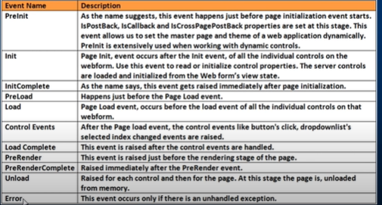

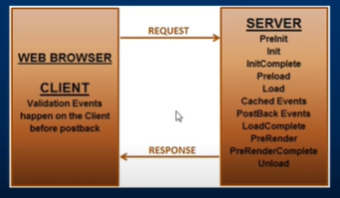

**Types of events in ASP.NET server controls**

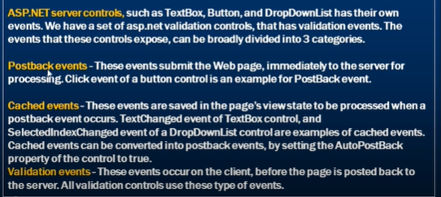

**SOME IMPORTANT PROPERTIES**

1. **AutoPostBack**
2. **EnableViewState – IF set to False, *this will omit the Cached Event to occur on server***

**VIRTUAL DIRECTORY**

**Virtual directory is something doesn’t exist physically, it maps to some physical location Like /MyApp node under Default Web Site of IIS which points to Some actual physical path.**

**Types of Navigation techniques**

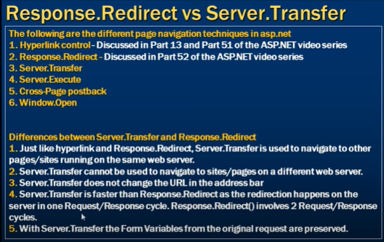

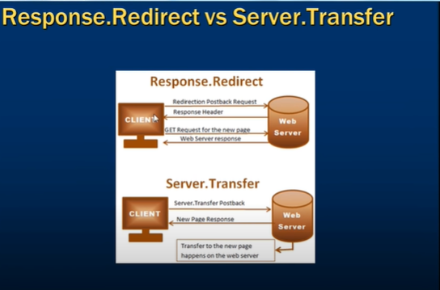

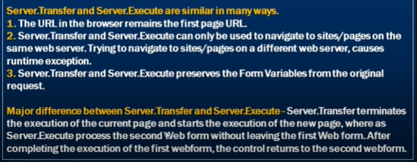

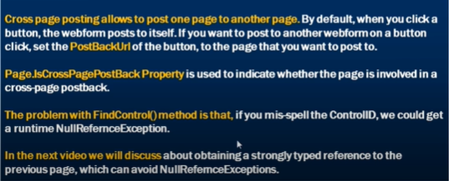

* **Get Posted Form Control data**
  + **Request.Form**
  + **Page.PreviousPage**

**Window.Open(param1,param2,param3,param4)—USEFULL**

**Server side control can call javascript function using OnClientClick**

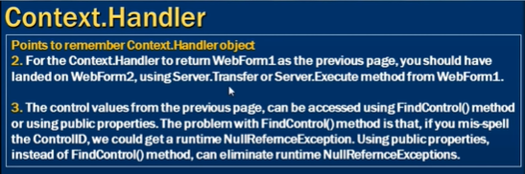

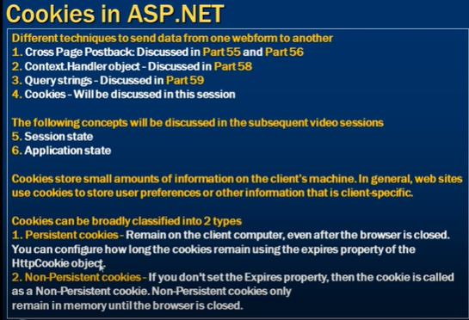

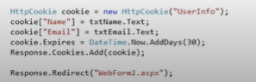

***Way to check whether cookies are enabled/disabled***

Request.Browser.Cookies tells if browser supports cookies or not



